Open control panel

Click on turn window features on or off

Enable Hyper-v and SBM 1.0

Running command

Enable-WindowsOptionalFeature -Online -FeatureName Microsoft-Hyper-V -All

Enable-WindowsOptionalFeature -Online -FeatureName "SMB1Protocol" -All

Download Vagrant and install it

vagrant box add hashicorp/bionic64

and select hyperv

vagrant box list to check if installed

Locate to wish your folder and initialize it

vagrant init hashicorp/bionic64

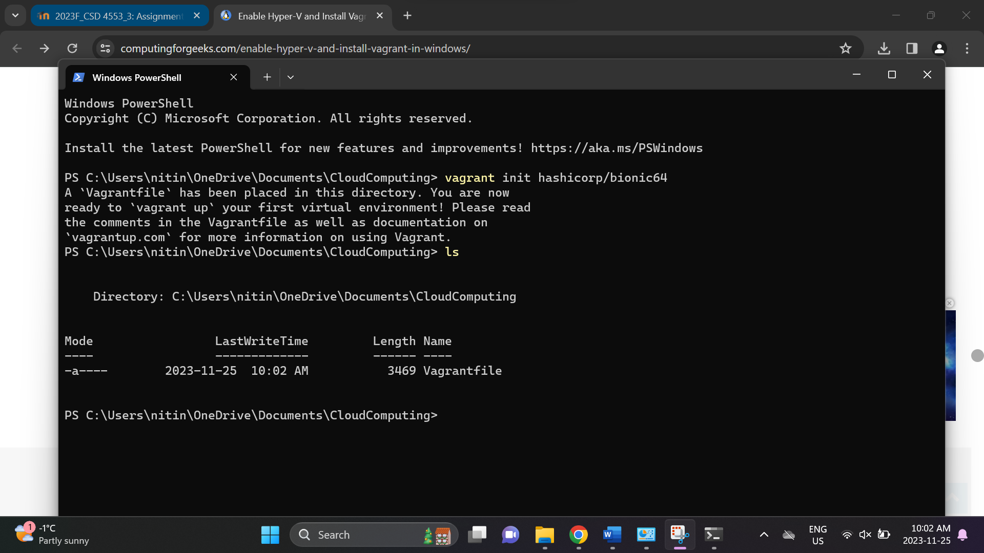

vagrant up --provider hyperv

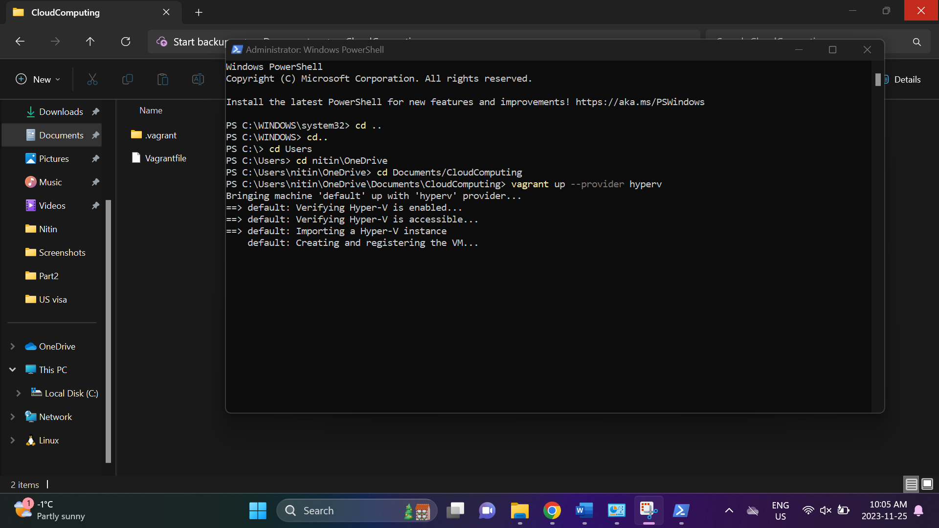

vagrant ssh

Creating a playbook in Ansible that installs Docker on a Ubuntu VM, pulls an image, and deploys it:

|  |
| --- |
| ---  - name: Install Docker dependencies  apt:  name:  - apt-transport-https  - ca-certificates  - curl  - software-properties-common  state: present  - name: Add Docker GPG key  apt_key:  url: https://download.docker.com/linux/ubuntu/gpg  state: present  - name: Add Docker repository  apt_repository:  repo: deb [arch=amd64] https://download.docker.com/linux/ubuntu focal stable  state: present  - name: Update apt package cache after adding Docker repo  apt:  update_cache: yes    - name: Install Docker  apt:  name: docker-ce  state: present    - name: Ensure Docker service is running  systemd:  name: docker  state: started  enabled: yes  - name: Deploy Docker Container  hosts: localhost  become: true  vars:  docker_image: nitinnema/classarr:1.0.1  container_name: classarr  host_port: 3000  tasks:  - name: Pull Docker Image  docker_image:  name: "{{ docker_image }}"  state: present  - name: Run Docker Container  docker_container:  name: "{{ container_name }}"  image: "{{ docker_image }}"  state: started  ports:  - "{{ host_port }}:3000"  - name: Wait for the container to be reachable  wait_for:  host: "http://localhost:{{ host_port }}"  state: started  timeout: 60 |

Forwarding the port 3000 from Ubuntu VM to my local machine using the following command:

curl 10.51.227.72:3000

